STATS FOR JOSIE FRAMPTON

Statistics
Female and male
N | Valid | 31
N | Missing | 0

Female and male
 |  | Frequency | Percent | Valid Percent | Cumulative Percent
Valid | Female | 22 | 71.0 | 71.0 | 71.0
Valid | Male | 9 | 29.0 | 29.0 | 100.0
Valid | Total | 31 | 100.0 | 100.0

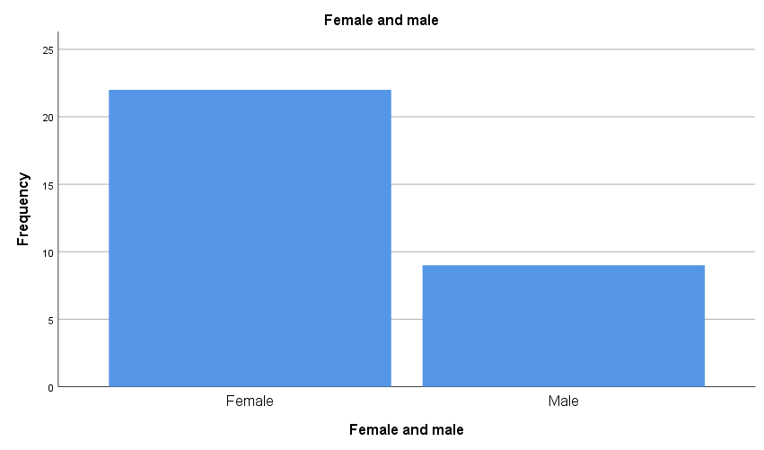

Residence
 |  | Frequency | Percent | Valid Percent | Cumulative Percent
Valid | Brooklyn | 8 | 25.8 | 25.8 | 25.8
Valid | Bronx | 1 | 3.2 | 3.2 | 29.0
Valid | Queens | 6 | 19.4 | 19.4 | 48.4
Valid | Westchester | 5 | 16.1 | 16.1 | 64.5
Valid | Connecticut | 1 | 3.2 | 3.2 | 67.7
Valid | Massachusetts | 6 | 19.4 | 19.4 | 87.1
Valid | Rhode Island | 2 | 6.5 | 6.5 | 93.5
Valid | Other | 2 | 6.5 | 6.5 | 100.0
Valid | Total | 31 | 100.0 | 100.0

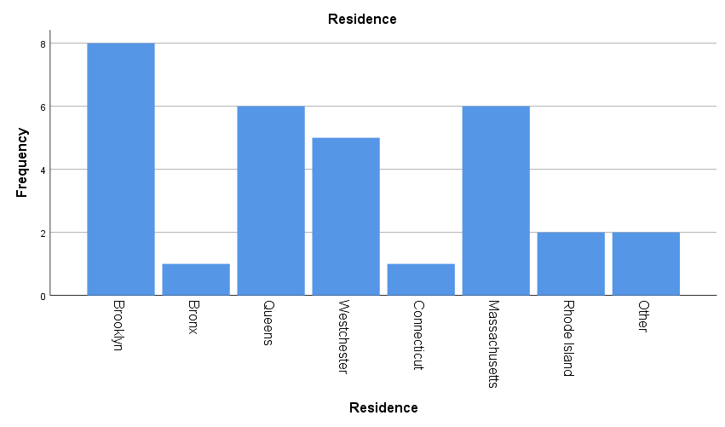

Years as SDA
 |  | Frequency | Percent | Valid Percent | Cumulative Percent
Valid | Under 5 | 1 | 3.2 | 3.2 | 3.2
Valid | 11-20 | 3 | 9.7 | 9.7 | 12.9
Valid | 21-30 | 4 | 12.9 | 12.9 | 25.8
Valid | 31-40 | 11 | 35.5 | 35.5 | 61.3
Valid | over 40 | 12 | 38.7 | 38.7 | 100.0
Valid | Total | 31 | 100.0 | 100.0

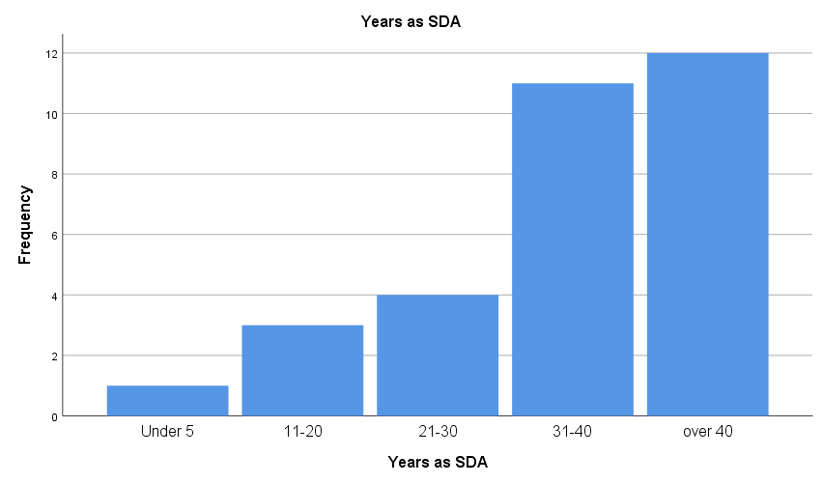

First Unleashed attended
 |  | Frequency | Percent | Valid Percent | Cumulative Percent
Valid | Yes | 17 | 54.8 | 58.6 | 58.6
Valid | No | 12 | 38.7 | 41.4 | 100.0
Valid | Total | 29 | 93.5 | 100.0
Missing | System | 2 | 6.5
Total |  | 31 | 100.0

